Safeguarding and Protecting Children Policy
Lowestoft Rowing Club follows the ARA Safeguarding and Protecting Children Policy (http://www.ara-rowing.org/upload/files/Association/Policies/SafeguardingPolicyV14.pdf)

The Child Welfare Officer is Paul Gurbutt. His role is to:
- To provide information and advice on child protection within the club.
- To ensure that the club adopts and follows the ARA Safeguarding and Protecting Children Policy and procedures and
- promote awareness of the policy within the club.
- Be a confirmation signatory, verifying the identity of individuals completing CRB Disclosure application forms.
- Keep records of all those who have been vetted within the club to ensure that CRB checks are updated on at least a three-yearly basis.
- Receive information from club staff, volunteers, young people or parents and carers who have child protection concerns and record it.
- Assess the information promptly and carefully, clarifying or obtaining more information about the matter as appropriate.
- Make a formal referral to a statutory child protection agency if appropriate.
- Report any referrals or concerns to the ARA child protection officer as soon as possible in line with ARA procedures.
- Ensure that appropriate information is available at the time of referral and that the referral is confirmed in writing, under
- confidential cover, using the ARA incident report form.
- Advise the club officers regarding the appropriate levels of child protection training and/or guidance for all adults working
- with children in the club.
- Promote a child-centred approach within the club, eg maintain the junior section notice board and promote good practice.
- Advise the club of further child protection training opportunities.
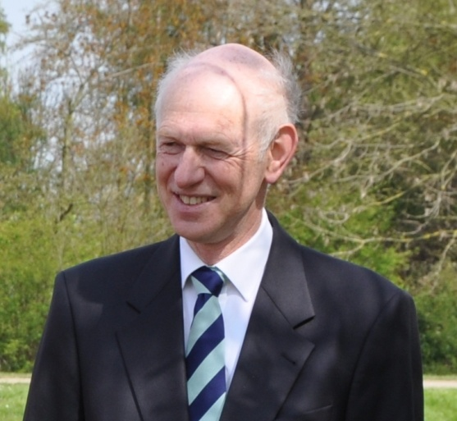
Paul Gurbutt – Child Welfare Officer

